**AIM: SCENARIO PLANNING & MENTAL MODELS**



***MyHome - IoT Based Smart Home Automation System***

***Submitted to: Ms. Monali Rajput***

***Submitted by: Narender Keswani(24)***

***FYMCA-B***

**Scenario Making**

The process of making plans and assumptions on the future of the business and

keeping in mind the changes occurring in the work environment is known to be

scenario planning.

To be a bit more precise in this matter, we can say that it is the basic method which the

businesses these days use to find out the certain uncertainties and the ‘realities’ which

might take place in the business’s future.

Scenario planning enables decision-makers to identify ranges of potential outcomes

and estimated impacts, evaluate responses and manage for both positive and negative

possibilities.

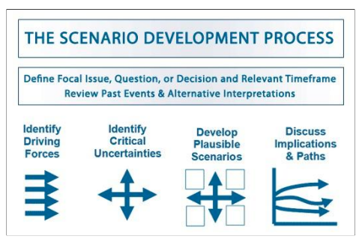

The process to create your own scenarios includes:

1. Identify your driving forces
2. Identify your critical uncertainties
3. Develop a range of plausible scenarios
4. Discuss the implications

Basic tasks of MyHome:

|  |  |  |
| --- | --- | --- |
| **Sr.no** | **Name** | **Description** |
| 1 | Spalsh Screen | This is the Splash screen which shows logo and loading animation. |
| 2 | Bottom Nav Bar | This is the main controller which will be displayed to the user after user logs in. This activity controls all the activities and fragments. Redirects it whenever user click on the event. This activity shows bottom navigation bar and side navigation drawer. Also, it manages the Shared Preferences of the user and other settings like parental control and logout, etc. |
| 3 | Dashboard | This is the main dashboard which shows Air monitoring and the control of the electrical ports. (Switching on and switching off) |
| 4 | Plant | This is a plant fragment which shows current moisture level of the plant and status of the plant. |
| 5 | Water | This is a water fragment which shows current water tank level with wave animation. |
| 6 | Report Problem | This a activity where user can report the problems and also give suggestions to the app developer. |
| 8 | Login | This is login activity where the user will enter the credentials. If credentials are correct then the user will be redirected to OTP Verification. |
| 10 | Otp Verification | This OTP verification activity will send an OTP to registered email address. If OTP is correct then it will be redirected to Main Controller. |
| 11 | Change Password | This Change Password Activity allows users to change the current password. Where user enters the old password and new password. |
| 12 | Edit Profile | This Edit profile Activity allows users to edit their names and email. |
| 13 | Forget Password | If the user forgets his/her password they can reset their reset their password using this activity. |
| 14 | Auto On Off | This Auto On Off Activity where user enter days, start time, stop time of the electrical port. The electrical port will be automatically on and off accordingly. |
| 16 | Last Month Electricity Usage | This fragment displays the Last Month’s Electricity Usage. (Current, Power, Bill, Energy) |
| 17 | This Month Fragment | This fragment displays the This Month’s Electricity Usage. (Current, Power, Bill, Energy) |
| 18 | Today Electricity Usage | This fragment displays the Today’s Electricity Usage. (Current, Power, Bill, Energy, Frequency, Voltage, Power Factor) |
| 19 | Last Month Electricity Usage Graph | This activity displays the Last Month’s Electricity Usage Bar Graph [Statistics]. (Current, Power, Bill, Energy) |
| 20 | This Month Electricity Usage | This activity displays the This Month’s Electricity Usage Bar Graph [Statistics]. (Current, Power, Bill, Energy) |
| 21 | On Boarding Screen | This On Boarding Activity is a one time description of the app which is showed to user. |
| 29 | Settings | This is a Settings Activity where user can edit settings and preferences accordingly. |
| 30 | Chat Bot | This activity will let user to connect with the chatbot where user can command the request and bot will generate response. |
| 31 | FAQ | This activity will display the in general question that is mostly asked by the users. |
| 32 | Privacy Policy | This activity contains privacy policy of using the app. |

**Scenario #1:**

Joel is a photographer and often travels to distant places for work. In morning rush, at times he forgets to switch off some appliances causing rise in electricity bill as well as increasing chances of electrical mishap.  
  
One morning on way to work, Joel realises that he might have left the A/C  on. He was already in his bus and could not travel back home to switch it off.  
  
Using MyHome, Joel can monitor which appliances are running. He can from a remote place turn any appliances ON/OFF saving cost of electricity and improving the life of the appliance.  
  
He receives an alert notification from the MyHome app. On seeing the status of the A/C he quickly updates the status and switches off the device saving electricity and preventing any electrical mishap.

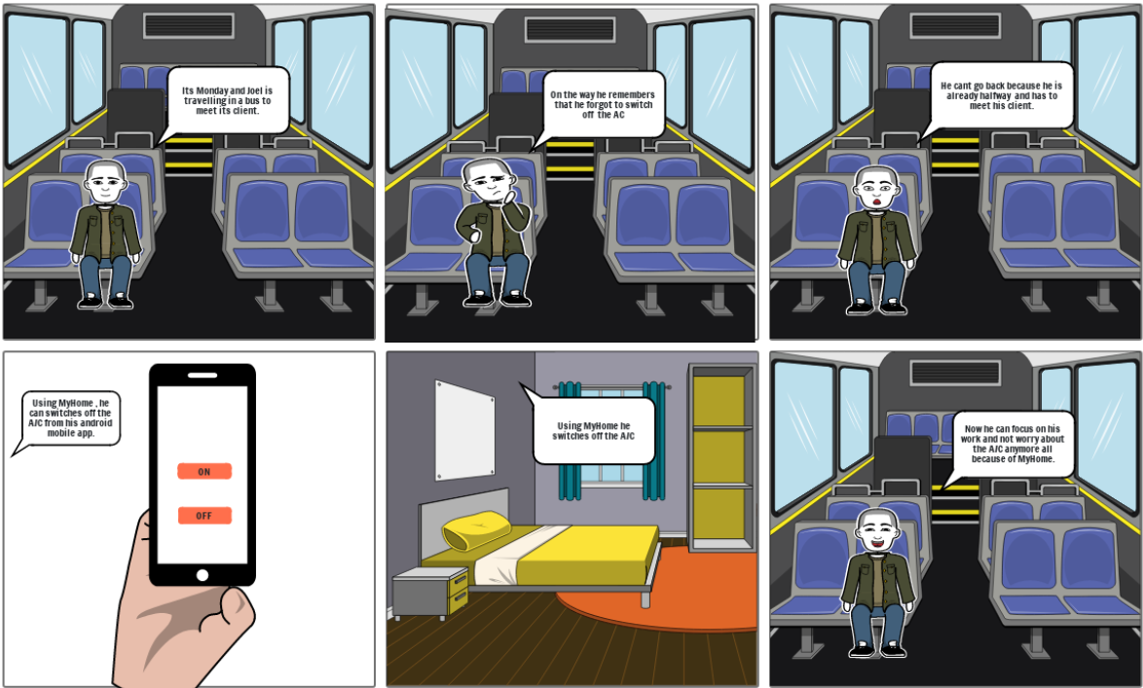

**Scenario #2:**

There are three roommates lives together in one flat, i.e. Sally, Maggie, John. Sally is always on the phone, and forgets to turn her bedroom light off and music off; before she has a nap. Maggie keeps her computer on even though she does not use it when she is on her phone. John leaves all the kitchen appliances on when making dinner. This month sally Maggie and john's bill has been the highest it has every been !!!. After buying MyHome they control all the electrical applicants and save their electricity bill. After 3 months of using the MyHome the roommates saved up to 40% of their electricity bills. The roommates could safely say they have made a smart save and has contributed in improving the environment.

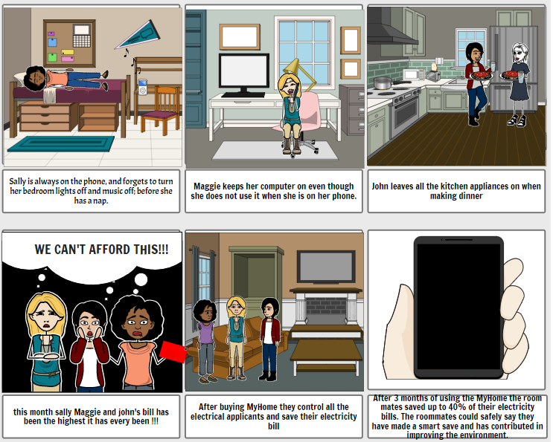

**What is a mental model?**

A mental model describes the way a person understands how to do something. It’s a map of the mental spaces a person cycles through in order to accomplish a goal. A mental model can help designers access design challenges from users’ perspectives. It’s laid out in clusters of “tasks” — thoughts, feelings, and the behaviors that arise from them — which are thematically grouped together. The tasks and groups can be mined for opportunities to reduce the cognitive load required for the user to accomplish their goal.

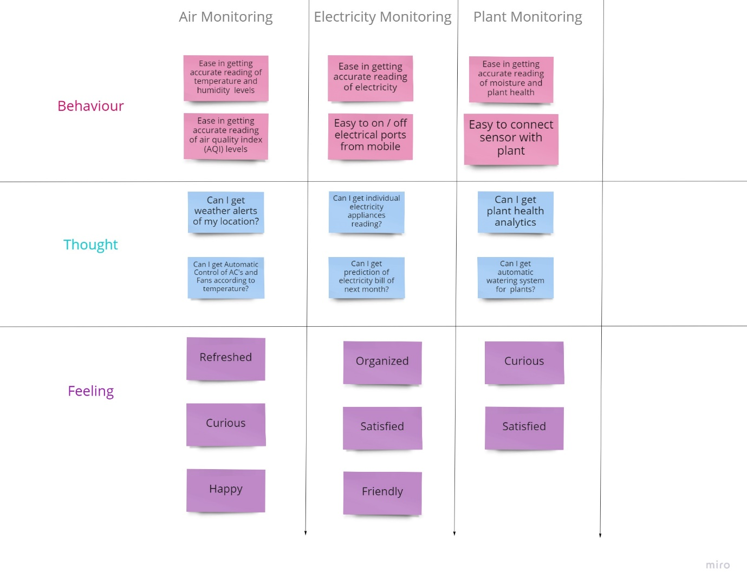

**CONCLUSION:**

We have successfully designed and framed scenarios and mental model for our application